### ***Project Report***

***1) INTRODUCTION***

***1.1 Overview***

* *This project is the evolution of electricity in the world.*
* It provides you the clear data on the usage of electricity all over the world.

1.2 Purpose

* In the century, electricity has become one of the basic requirements in day-to-day life.
* With this wonderful or magical power, we can prevent many hazardous threats that confronts us.

**2) PROBLEM DEFINITION &DESIGN THINKING**

**2.1 Empathy Map*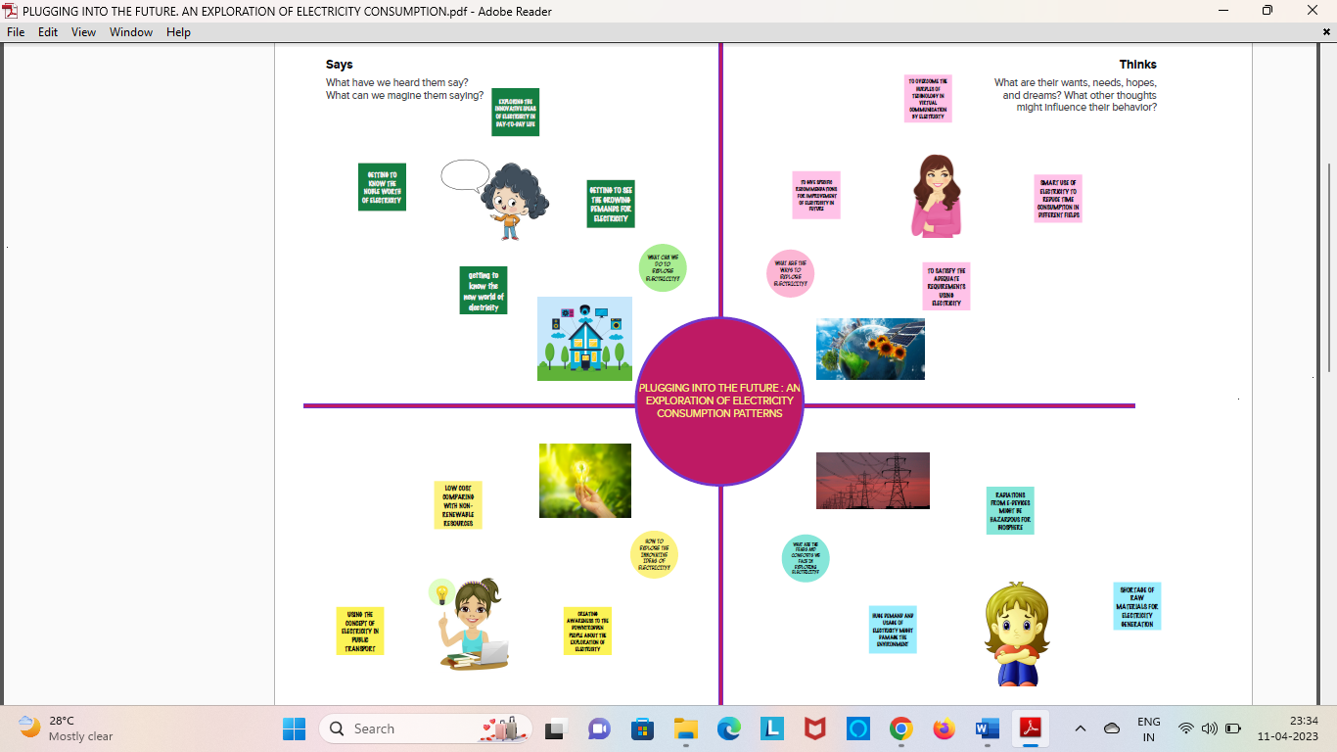***

**2.2 Ideation & Brainstorming Map**

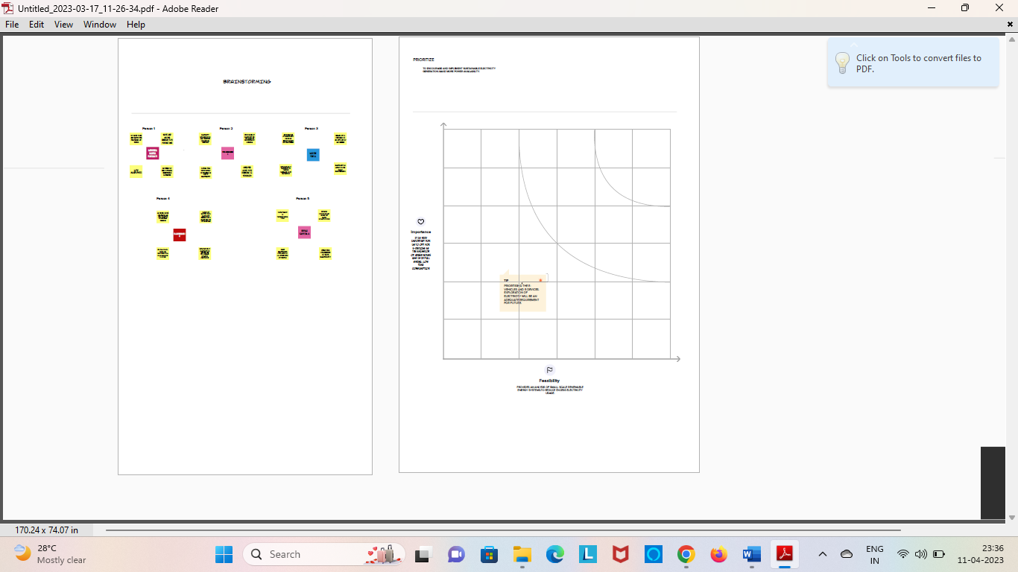

**3) RESULT**

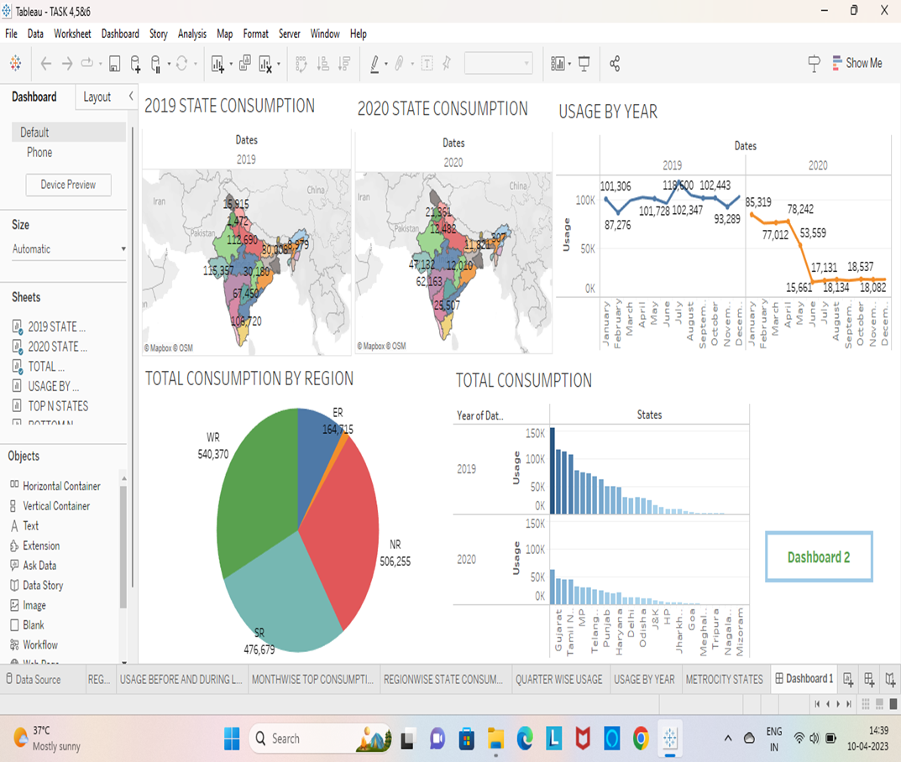

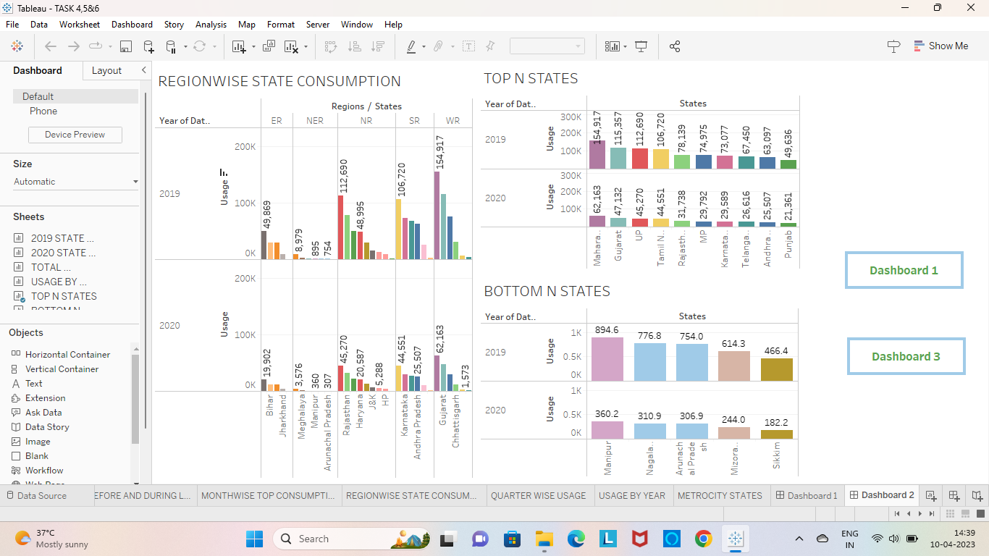

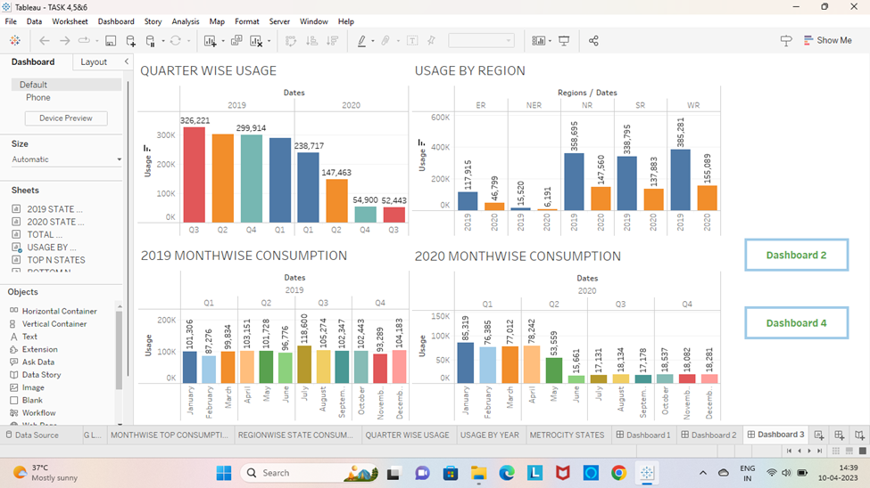

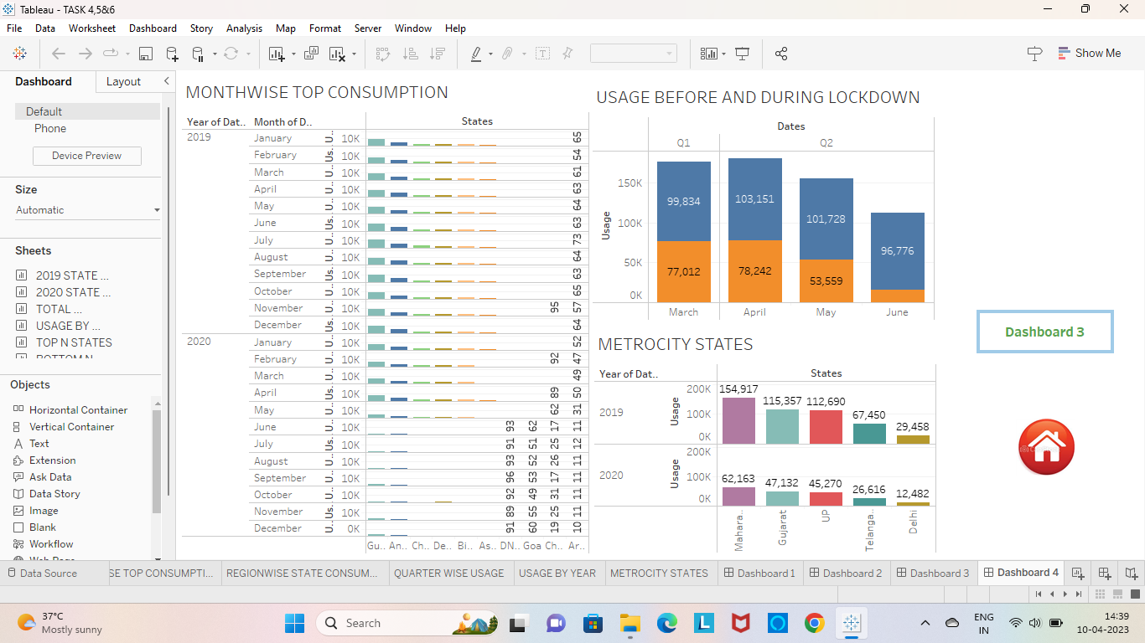

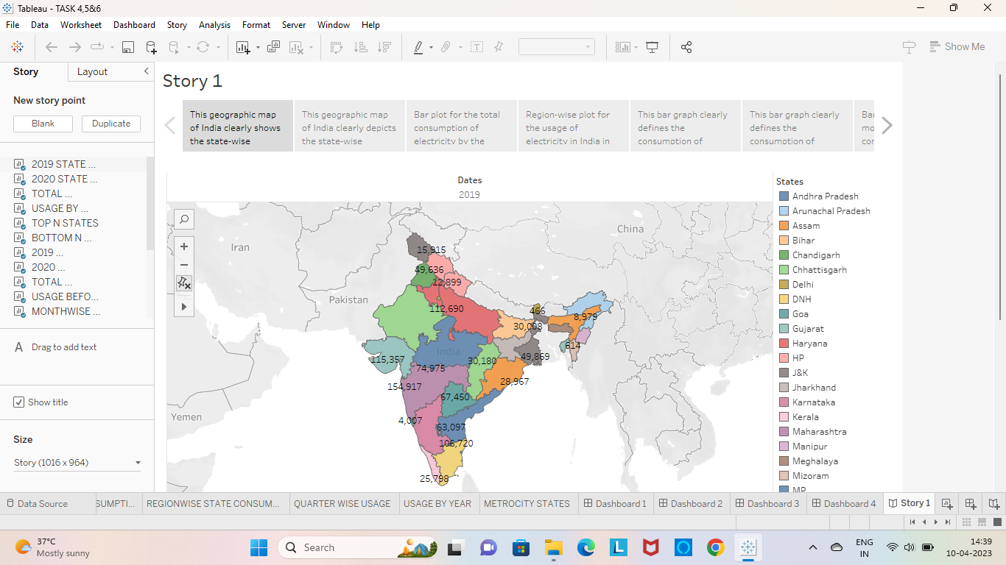

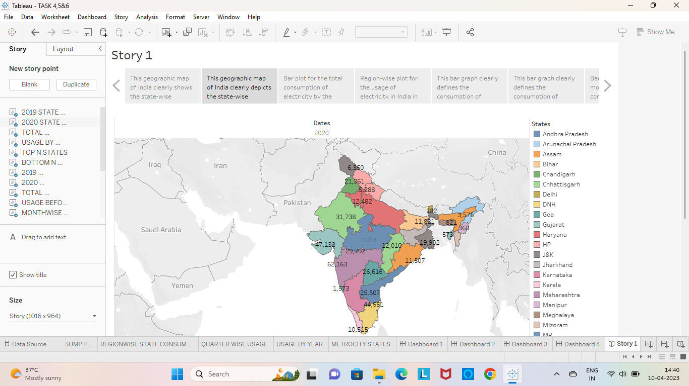

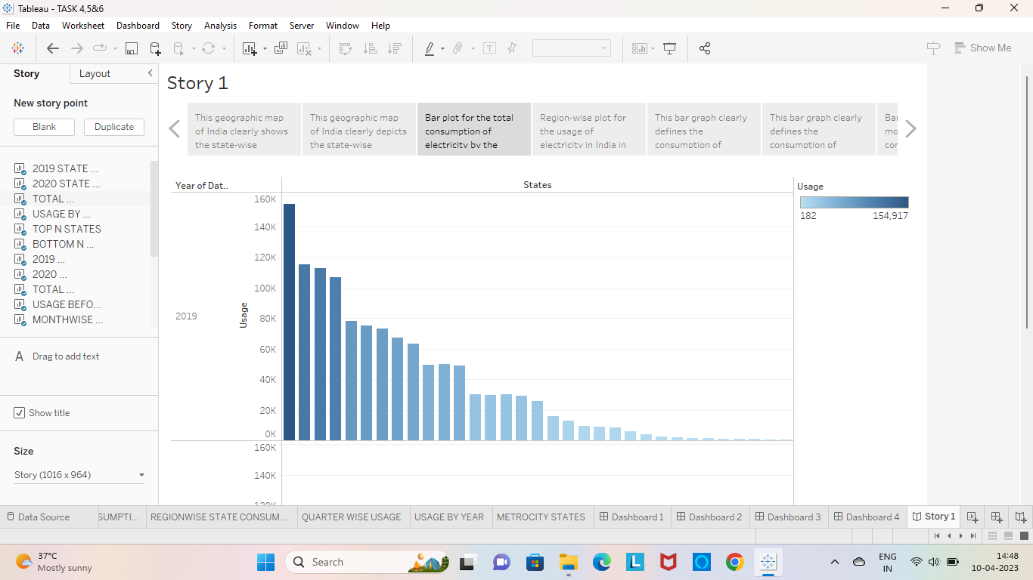

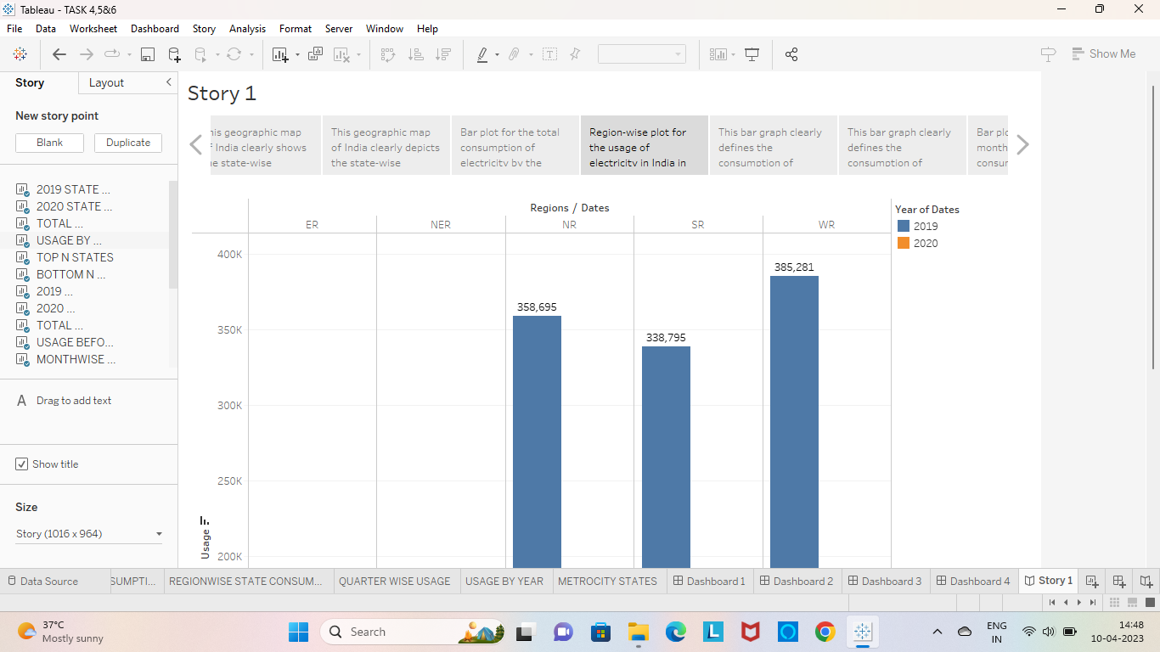

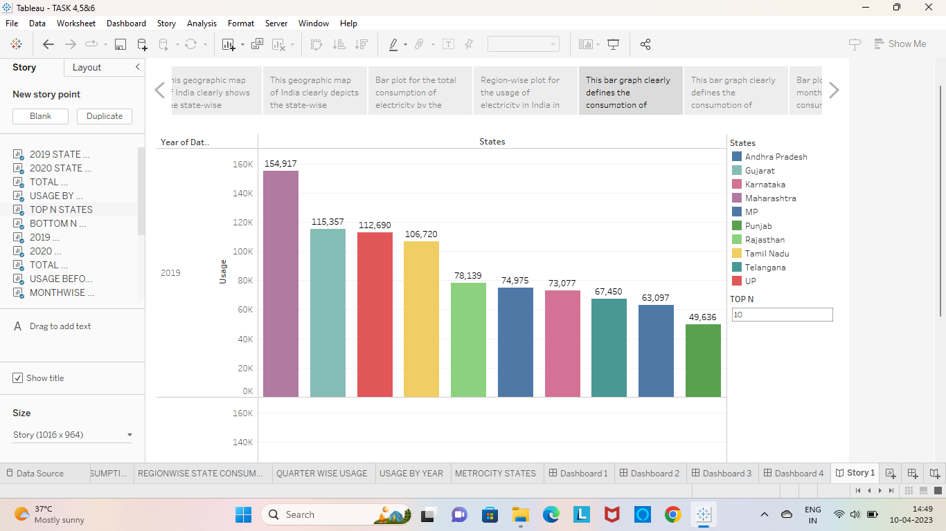

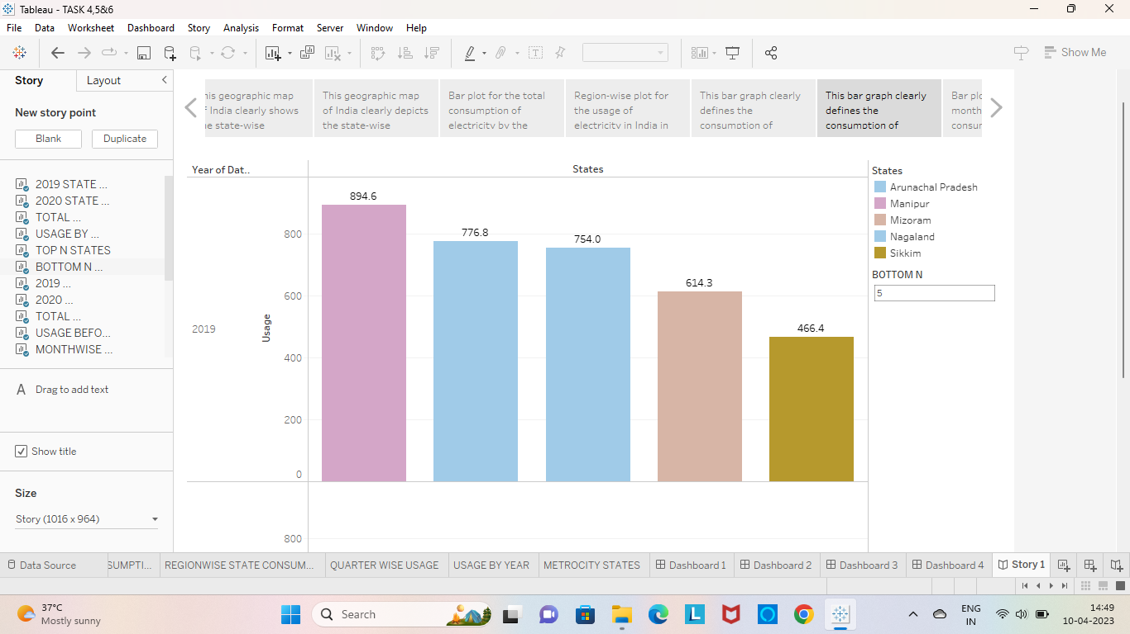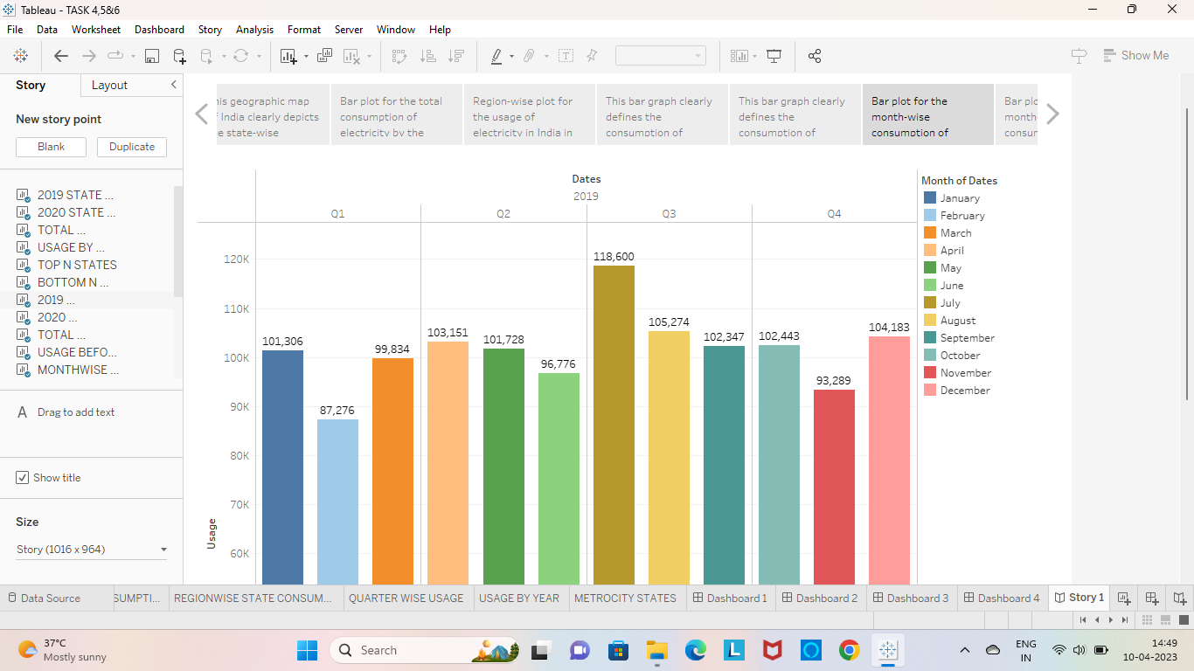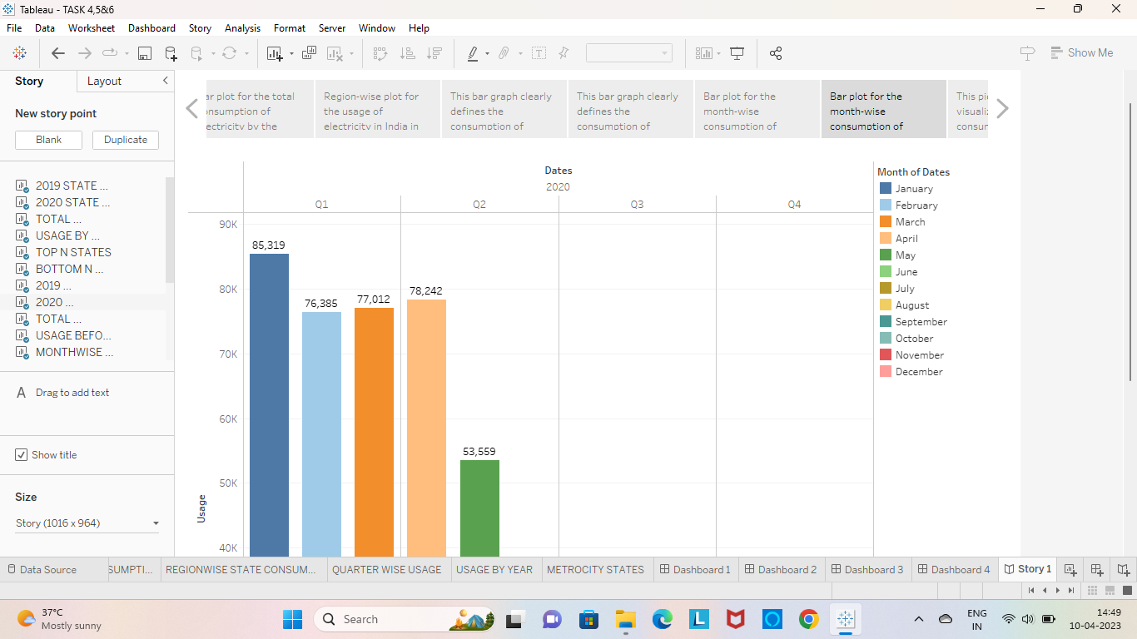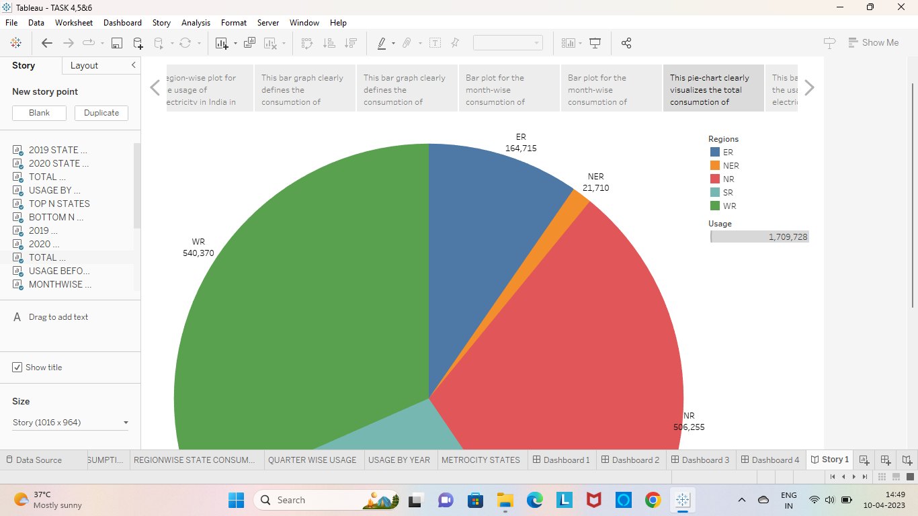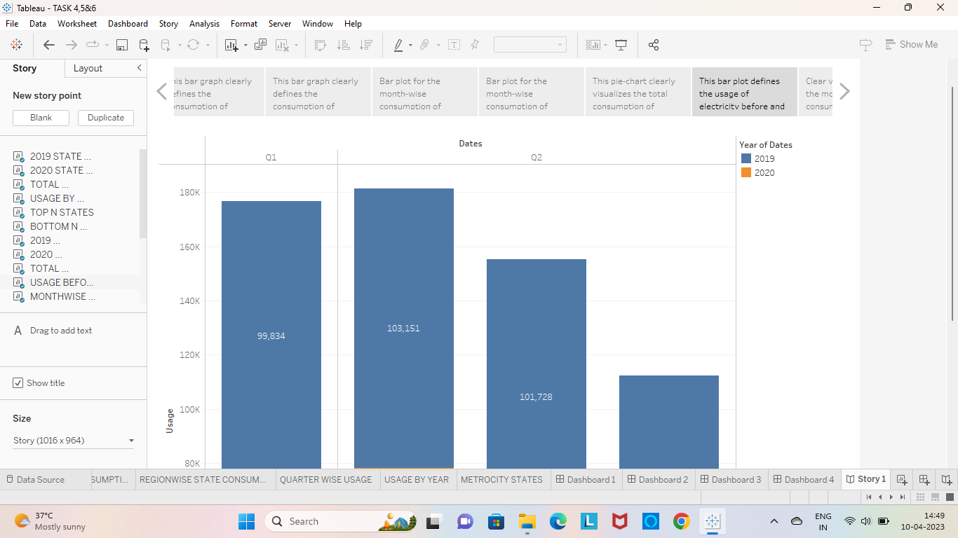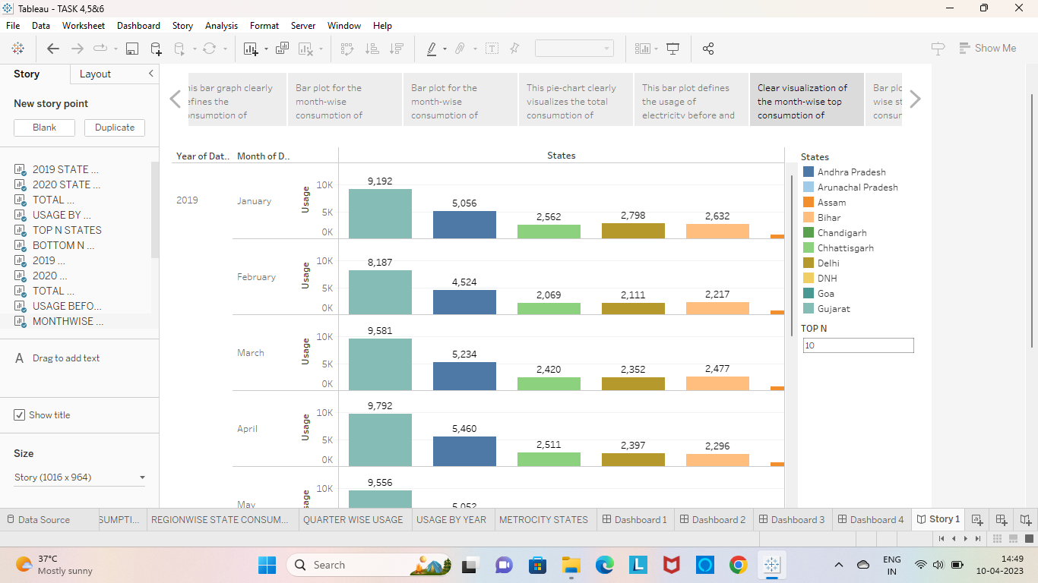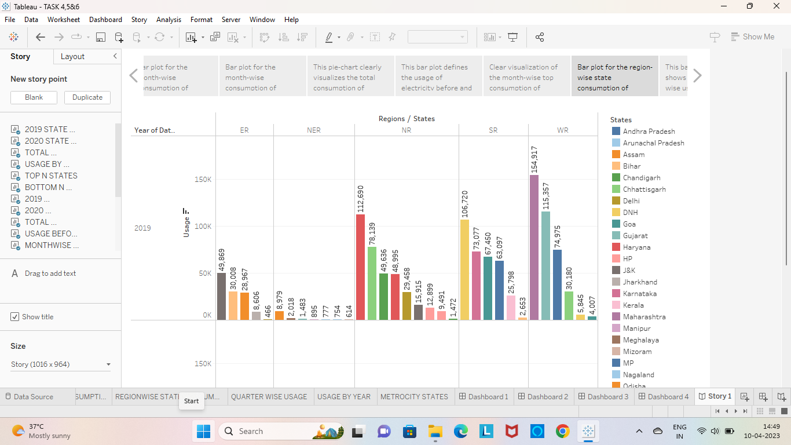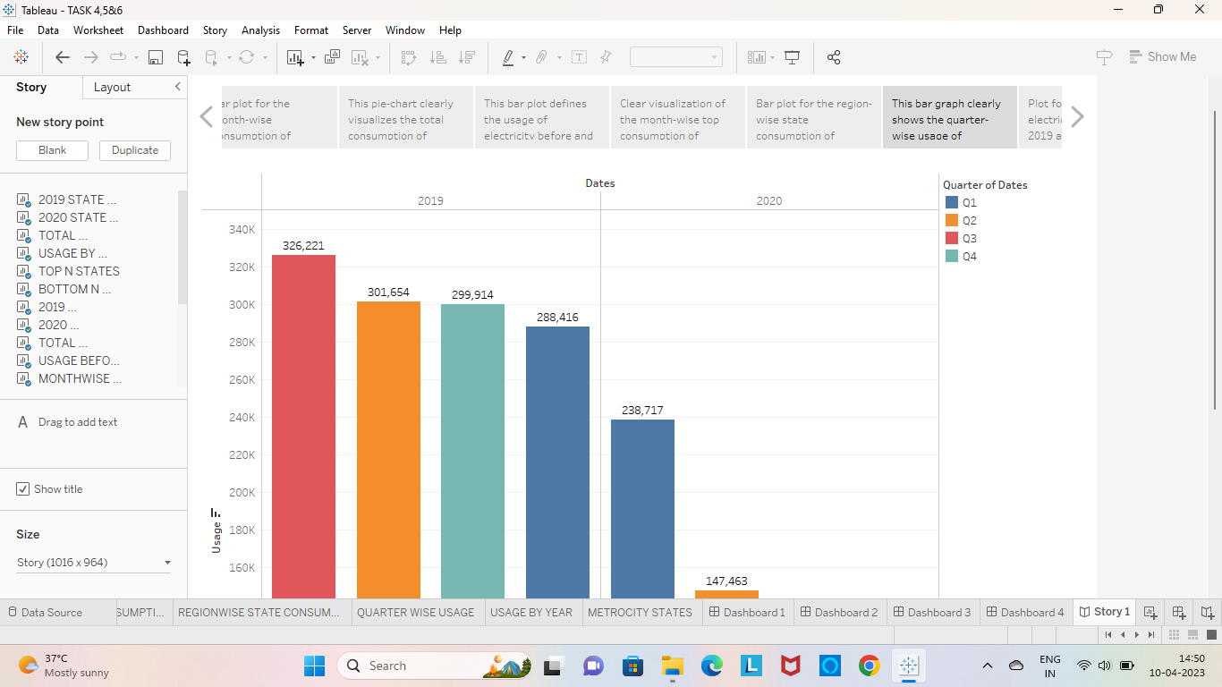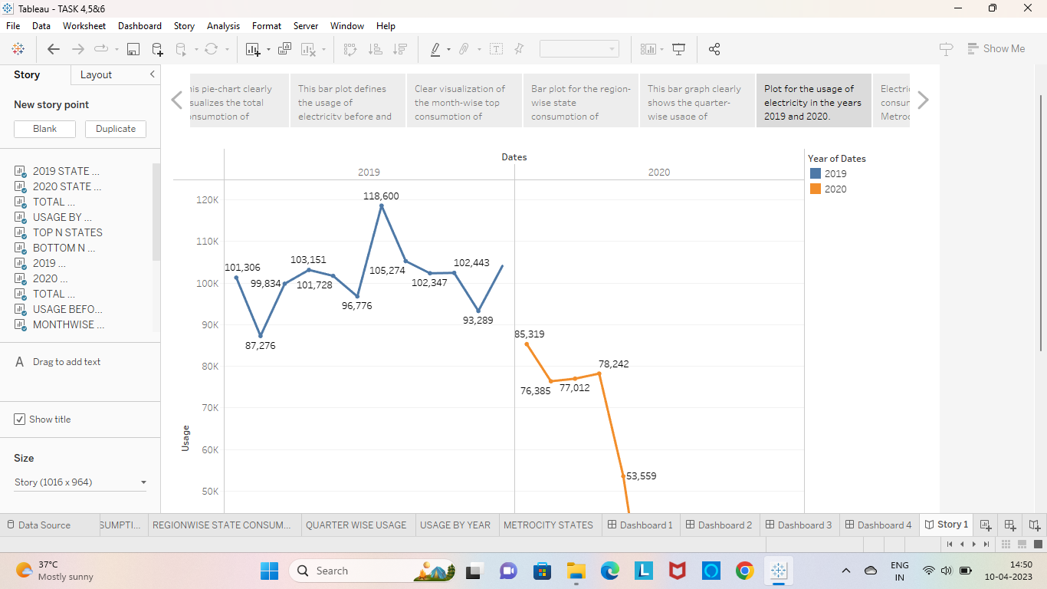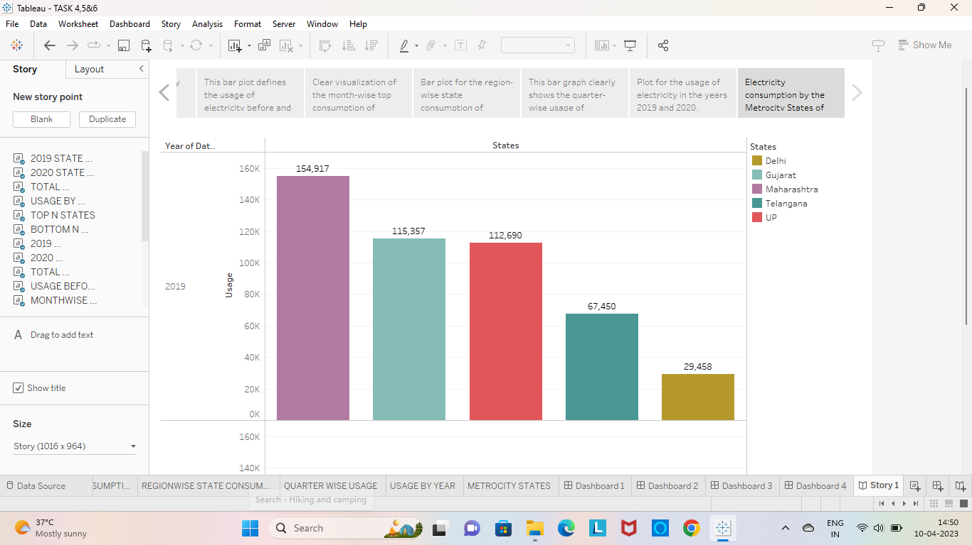

***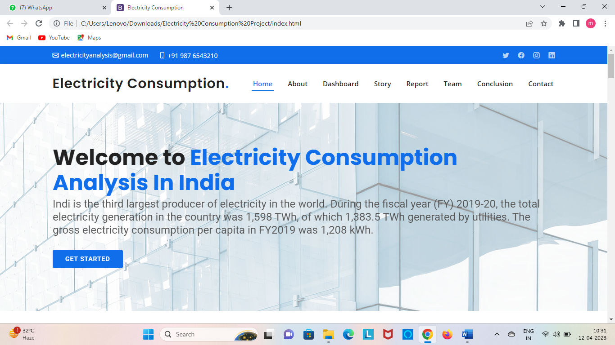*4) ADVANTAGES & DISADVANTAGES**

**Advantages**

* Electricity is a clean, safe cheap and convenient source of energy
* Low maintenance cost.
* More efficient
* Low and man power.
* Reduce green-house gas emission.
* Easy to use and move from one location to another.

**Disadvantages**

* Loss of biodiversity due to excessive radiation.
* Prolonged use of electricity becomes hazardous to health.
* Drought can affect power production.
* More power plants cause pollution.

1. **APPLICATIONS**

* We can reduce man power and time by applying elementary.
* Usage of electricity in machinery appliance will be budget free and ecofriendly.
* So, we can go green by using e-vehicles instead of using vehicles which require fuel like diesel, petrol.
* Usage of e-vehicles should be encouraged.
* We can convert the public transport which run in petrol, diesels into and vehicles.
* Charging stations for e-vehicles should be constructed.

1. **CONCLUSION**

In this project, we have analyzed the consumption of electricity by each state. We also got to know how to explore using electricity. Exploration of electricity wisely brings a lot of advantages but at the same time its excessive use might be a threat for the human health.

1. **FUTURE SCOPE**

* Using electricity wisely will reduce emission of green-house gases.
* Productive use of electricity might save time, energy and resources for the future generation.
* States using excess electricity like Maharashtra, Gujarat etc., should focus on saving electricity.
* States getting insufficient supply of electricity can be added in tableau analytics and it will be useful for future reference.

1. **APPENDIX**
2. **Source Code**

[**Electricity Consumption Project\index.html**](Electricity%20Consumption%20Project\index.html)